KIMS STUDENTFIRANDE 2014-06-11
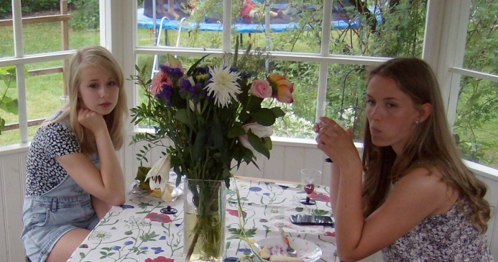
PAULINA VENDELA


KIM


KIM VICTORIA ULRIKA MIKAEL

